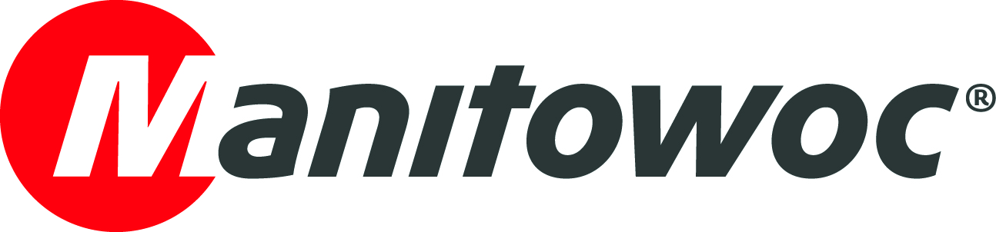
PRESS RELEASE

June 12, 2020

Nebraska Crane adds strength and flexibility to its fleet with a Grove GRT9165 rough-terrain crane
- Since its arrival at Nebraska Crane’s facility, the Grove GRT9165 rough-terrain crane has been working non-stop: first performing maintenance work on wind turbines and currently helping with the construction of a large parking garage.
- Because of its strong load chart, increased boom length and easy maneuverability, the crane can work on job sites typically performed by small crawler cranes.
- Grove’s dealer support network and low cost of ownership were factored into Nebraska Crane’s purchase decision.
As construction jobs require heavier picks within spaces that get more constrained every day, Nebraska Crane was on the lookout for a strong, high-capacity crane, but compact enough to easily maneuver in all kinds of job sites. A big fan of Grove cranes — 95% of its rough-terrain fleet is Grove — the Kearney, Nebraska-based rental company decided to purchase Grove’s longest-reaching, highest-capacity rough-terrain crane: the GRT9165.
The crane has been working non-stop since its arrival at Nebraska Crane’s facility in December of last year, performing maintenance work on wind turbines in Iowa and, most recently, assisting with the construction of a large parking garage in Nebraska, where it is currently setting precast concrete panels.
“We are very pleased with the performance of our new GRT9165. Being a Grove product, it’s exactly what we expected: it’s superior to competitor’s machines. We expect excellence and they deliver it every time,” said Ty Noyes, operations manager at Nebraska Crane. “Its strong charts and boom length provide fantastic capabilities in the field. This job at the parking garage, for example, would traditionally be done with a small crawler crane. But we were able to do it with the GRT9165 at a lower cost while adding more flexibility to the job site, as we can move this compact rough-terrain crane around where we need it.”

With a 165 USt-capacity, the GRT9165 features class leading load charts and a 205 ft six-section, pinned boom — 5 ft longer than the closest competing model. It has been designed for easy transport, with a compact overall height of 12.4 ft. It also has a hydraulically removable counterweight system and outrigger boxes, both of which are fully self-rigging, which eliminates the need for an assist crane during set-up. The new three-axle carrier with hydro-gas suspension on the rear axles provides the ability to adjust the height for transportation, in addition to providing a comfortable ride.

The GRT9165 also features Grove’s new, wider, full-vision cab with Crane Control System (CCS) for maximum operator comfort and intuitive and efficient operation.

“Operator comfort is an important factor for us. We really like the new cab design and how simple the crane is to run,” Noyes said.

Nebraska Crane’s rough-terrain rental fleet is deployed on job sites across the Midwest, and lately it has been largely used in the wind energy sector and commercial construction. As these cranes are often on the road, transportability and low cost of ownership — repair and parts availability — were crucial factors when purchasing the new machine.
“For the GRT9165, we looked at the strength of the charts and boom length, and we also had in mind that Grove’s network of dealers does a lot for us out in the field — we rely heavily on them,” Noyes said. “At the end of the day, customers want the most capability that they can get at the lowest cost.”
The Bloomington, Minnesota dealer Aspen Equipment helped its long-time customer Nebraska Crane purchase its newest Grove model.

“We are thrilled to continue supporting Nebraska Crane’s success with the new Grove GRT9165. The only rough-terrain crane of this size in the Nebraska market should give them a major competitive advantage with its outstanding capabilities,” said Todd Foster, president of Aspen Equipment. “I thank Doyle Benson, president of Nebraska Crane, and his team for continuing to trust in Aspen Equipment and Manitowoc to meet their unique business needs”.

To learn more about the GRT9165, click here.

-END-

CONTACT
Amy Marten
Manitowoc
T +1 920 683 6345
amy.marten@manitowoc.com

ABOUT THE MANITOWOC COMPANY, INC.
The Manitowoc Company, Inc. (“Manitowoc”) was founded in 1902 and has over a 117-year tradition of providing high-quality products and support services that are tailored to customers’ needs. Its 2019 net sales were approximately $1.83 billion. Manitowoc is one of the world's leading providers of engineered lifting solutions. Through its wholly-owned subsidiaries, Manitowoc designs, manufactures, markets and supports comprehensive product lines of mobile telescopic cranes, tower cranes, lattice-boom crawler cranes, boom trucks and industrial cranes under the Grove, Potain, Manitowoc, National Crane, Shuttlelift and Manitowoc Crane Care brand names.

THE MANITOWOC COMPANY, INC.
One Park Plaza – 11270 West Park Place – Suite 1000 – Milwaukee, WI 53224, USA
T +1 414 760 4600
www.manitowoc.com

